Assignment 5

Try to implement your own operators inspired by differential evolution. You have several options (choose some of them, or create your own). Compare the algorithms again on a set of function from the BBOB benchmark, select both separable and non-separable functions.

1. Implement the differential evolution directly.
2. Try to use more than two individuals in the differential mutation.
3. Try to change the parameters F and CR in an adaptive manner (or randomly).

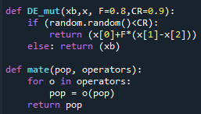

Graphs obtained:

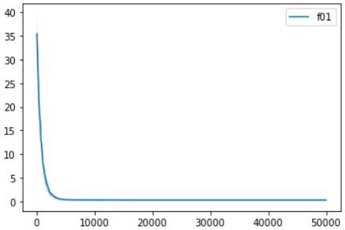

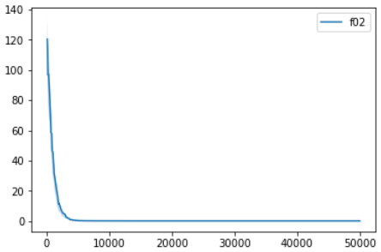

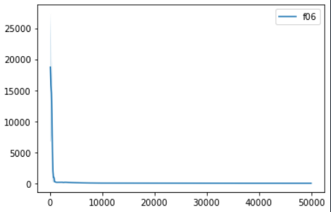

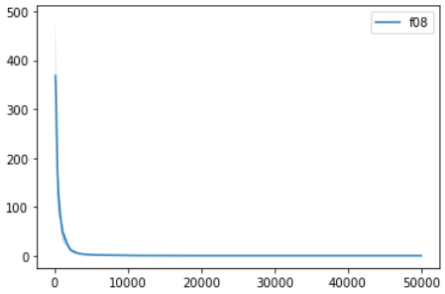

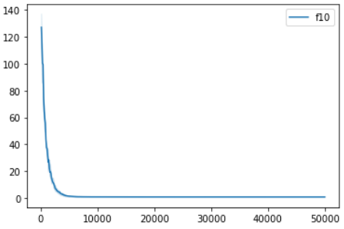

Legend Name -> function

f01 -> sphere

f02 -> ellipsoidal

f06 -> attractive_sector

f08 -> rosenbrock

f10 -> rotated_ellipsoidal

Trailing with F & CR.

When, F = 0.3 & CR = 0.6, results were quite maximum.

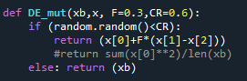

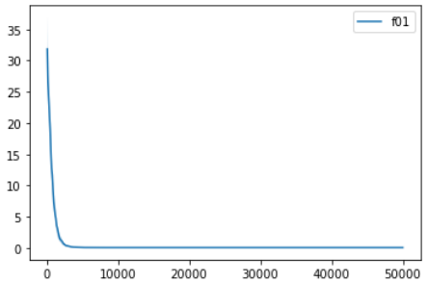

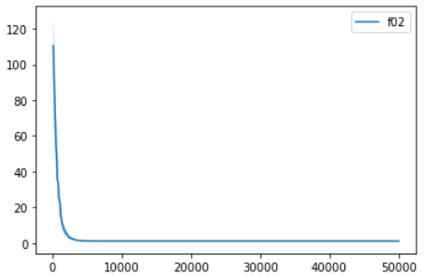

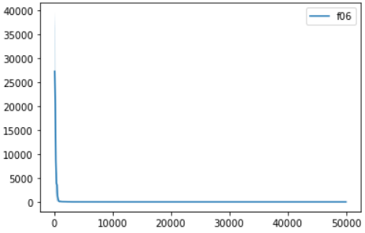

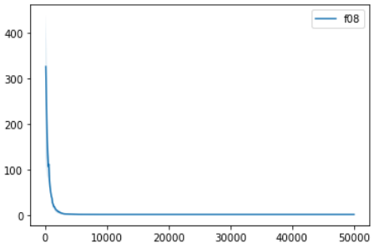

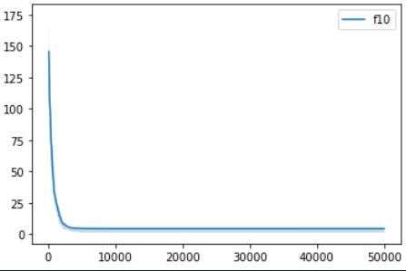

When F=1 & CR=1,

